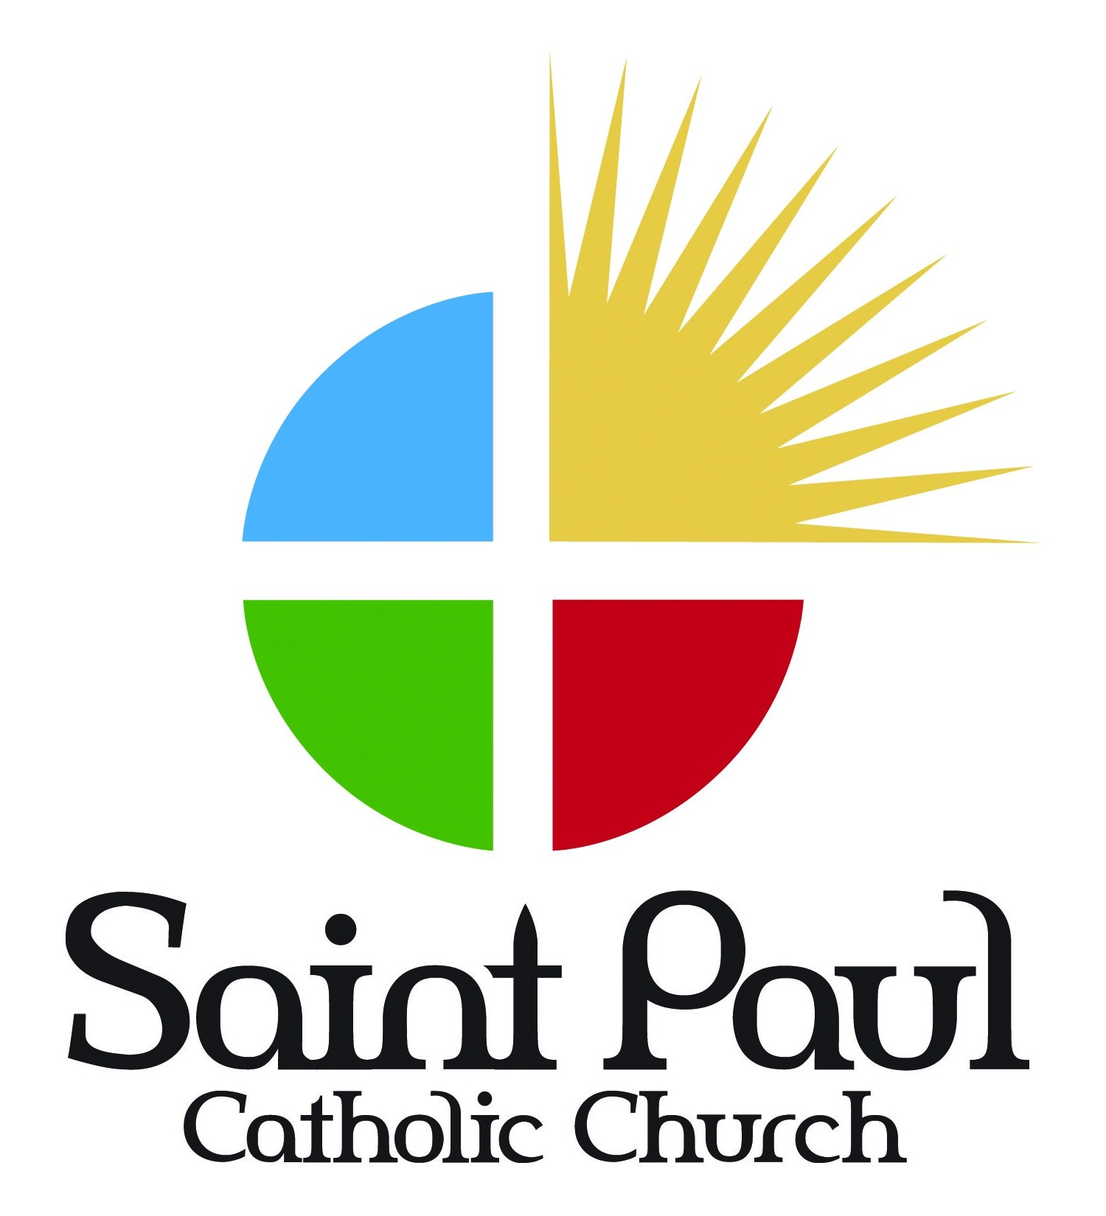

Parent Handbook

Parish Religious Education
Youth Group

CONTACT INFORMATION

Church Office
5971 Highway 25
Flowood, MS 39232
(601) 992-9547

Coordinator of Religious Education
Sarah O’Donnell
rel.edu@saintpaulcatholicchurch.com
(601) 292-6089

Youth Director
Cory Head
youth@saintpaulcatholicchurch.com
(601) 292-6084

Office Hours
Monday: Closed
Tuesday-Friday: 8:00 am-4:00 pm

Website
www.saintpaulcatholicchurch.com

Dear Friends,

Greetings and good wishes to you all as we begin another school year. I am grateful that your family is enrolled in our Religious Education and Youth Program here at St. Paul. We have a comprehensive program that runs from 3 years old through 12th grade. We are very proud of our program and we are grateful for our leaders Sarah O'Donnell and Cory Head. We are very grateful also for all of the volunteers who work very hard as teachers, assistants, and helpers in each of the classes. Without these great volunteers we would be unable to provide this program.

If you would like to help us in this program, we certainly could use your assistance. You may work in the forefront or the background as you please, and we would be grateful for your support and participation. You are the first and greatest teachers of your children in the ways of faith. We are the secondary teachers and are there to support you in the work you are doing in raising your children in the Catholic Faith. In the Rite of Baptism there is that beautiful blessing addressed to the father specifically, and it says:

"You and your wife will be the first teachers of your child in the ways of the faith. May you also be the best of teachers bearing witness to the faith by what you say and do in Christ Jesus Our Lord!"

We have invested a great deal of time, money, effort, personnel, and training in trying to make our programs as fruitful as possible. Your cooperation with us, your support of our programs and your ongoing efforts to bring your children to the programs is extremely important in attaining our goals.

We are looking forward to many blessings throughout this year and praying for an outpouring of the Holy Spirit upon all of us as we journey together. If there is anything further we can do for you in assisting you as you raise your children in faith, please do not hesitate to call on us.

Sincerely Yours,

Fr. Gerry

Fr. Gerry Hurley

from the
Office of Faith Formation & Youth

Dear Parents/Guardians:

We are very happy to welcome you and your children to our Religious Education and Youth programs. We hope your heart is open and ready to assist and support our efforts in sharing our Catholic faith with the young people of our parish.

We have wonderful adult volunteers who serve as “ministers of the Church” and are eager to help our students learn more about the Good News of Christ. Through their example, they model how to live a Christian life, both in celebrating the sacraments and living out their Christian values.

However, you are the primary educators of your children. It is living out your Catholic faith daily in the home with your family that imprints that faith on your children. Students learn by the example of those around them. Our programs are intended to supplement the religious formation they are receiving at home. We ask you to continue to take an active role in your child’s religious instruction. If religious education is important to you, it will be important to them.
The Eucharist is the center of our Christian life. As Disciples of Christ, we come together and worship Him every week. Religious Ed does not take the place of Mass. Students should continue to attend mass faithfully with their family.

Thank you for entrusting your children and their faith formation to us. We look forward to working with you. If you have any questions or concerns at any time, please do not hesitate to contact us.

Sincerely,

Sarah O’Donnell Cory Head
Coordinator of RE & Youth Youth Director

St. Paul Catholic Church
Religious Education & Youth

St. Paul’s Religious Education and Youth programs provide religious instruction to children 3 years through 12th grade. We follow the guidelines of our Diocesan Office of Faith Formation. After two years of sacramental preparation, students receive the Sacraments of Reconciliation and First Holy Communion in the second grade and Confirmation in the eleventh grade.

Curriculum
Children three years through third grade receive instruction through the Catechesis of the Good Shepherd. This is a Montessori style program that incorporates instruction in the catholic doctrine through hands-on experience. Grades four through six are currently using materials from the Loyola Press series, Christ Our Life. However, efforts are currently underway to extend the Catechesis of the Good Shepherd program through sixth grade by the 2017-2018 school year.
Our Youth Group consists of students 7th-12th grades. Our 7th & 8th grade students follow a Middle School program from Loyola Press. Our 9th-12th grades receive instruction through various programs that include materials from Loyola Press, Youth Access and Theology of the Body. Our Youth Group experience also includes guest speakers, testimonials, music, service and fellowship.

Sacramental Preparation
Reconciliation & Eucharist: Immediate preparation for these sacraments is provided in the Second Grade Curriculum; however, candidates should be attending our formal religious education program at least one year prior to this sacramental year.

The first half of the year focuses on sin, the Examination of Conscience and the Sacrament of Reconciliation. Parents will be invited to participate in a retreat with their child prior to the First Reconciliation Service which is held in the month of November. This is a mandatory retreat and at least one parent is required to attend. Parents are also encouraged to foster the appreciation for the sacrament of Reconciliation by their own example.

The second half of the year is devoted to the study of the sacrament of Jesus’ Body and Blood, and to the celebration of the Mass. Parents are invited to attend the First Communion Retreat with their child prior to the First Communion Mass which will be held on a Sunday afternoon following the Easter Celebration. The First Communion Retreat is mandatory and at least one parent is required to attend with their child.
Dates and times for retreats and services will be announced at the beginning of the school year. Prior to receiving these sacraments, the office must receive a copy of the child’s baptismal certificate, unless they were baptized at St. Paul. It is also understood that the child, along with the family, is attending Mass each week, as well as all Sunday religious ed classes.

Confirmation: Immediate preparation for this sacrament is provided in the 11th grade curriculum; however candidates should be attending Youth Group at least one year prior to this sacramental year.

The preparation program combines classroom instruction, service opportunities and spiritual experiences. Celebration of the sacrament usually takes place after Easter. A time and date will be announced as soon as it is scheduled by the Bishop’s office.

Students are required to attend all scheduled classes and the Confirmation Retreat weekend which will be announced at the beginning of the school year. Candidates are also expected to attend mass weekly and sign in at the back of the church. If the student attends a different church, they are required to bring a signed bulletin from the priest of that parish. Students will also participate in a service project which will be decided upon at the beginning of class.

Registration
- Parents and guardians should be registered parishioners of St. Paul Parish.
- Students must be registered for Religious Education & Youth Group before the first class. This may be done online through our church website.
- Fees: $30 for one child; $50 for two children; $75 for three or more children.
- Parish Parental Consent form must be signed and returned for all students.
- Diocesan Liability Waiver form must be signed, notarized, and returned for all high school students (7th-12th grades). If there is already a copy on file from the previous year, only the Annual Update Form is needed.

Attendance
- Classes for children 3 years through 6th grade meet on Sunday mornings after the 8:00 am Mass, beginning at 9:15 am – 10:15 am.
- Our Youth Group, 7th-12th grades, meets on Wednesday evenings from 6:00 pm-
8:30 pm. Students will enjoy a meal together, group activities and classroom instruction.
- Because classes meet only once a week and we cover the full course curriculum for each grade, attendance is very important.
- Attendance is especially important for those students completing a sacramental year. Therefore, any student in our First Communion or Confirmation Program who has excessive absences must meet with the Coordinator of Religious Education and/or Priest to determine if the student is eligible to continue the program for the current year and receive the scheduled sacrament.

Student Behavior Policy
- Students are not to engage in any behavior that would endanger the health or safety of themselves or any other person.
- Use of alcohol and tobacco of any kind are prohibited.
- Respectful and courteous behavior toward catechists, adult volunteers, and peers is expected of all students.
- If a student’s behavior becomes rude or disruptive, he or she will be asked to leave the classroom and meet with the Coordinator of Religious Education (CRE) or Youth Director. If deemed necessary, the parent will be notified.
- If the student’s behavior is not improved and is asked to leave class a second time, the parents will definitely be notified and risk not being able to return.
- If the disrespectful behavior continues, the student will not be permitted to return for the current school year. If the student wishes to return the following year, he/she must meet with the CRE or Youth Director and Priest to seek permission.

Miscellaneous
- If your child has any medical issues, allergies, etc., please inform the CRE or Youth Director.
- Students should always arrive and be picked-up on time. Late arrival is very disruptive to class instruction. Also, late pick-up is disrespectful to the volunteers who have graciously given of their time to mentor your student.
- Phones and electronic devices are to be turned off and kept out of sight for the duration of all parish religious education activities. Catechists have the right to collect them if this rule is not adhered to.
- Necessary communication will be sent home to parents and guardians via flyer/
letter, email, website or church bulletin.
- In the event of inclement weather, please check the website or Facebook page for class cancellation. If the RCSD issues school closures due to inclement weather, we will follow their lead and also cancel classes.

